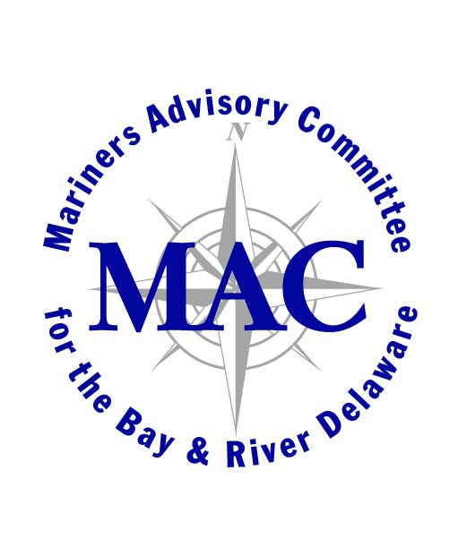
Memorandum

To: Mariners’ Advisory Committee Members and Interested Parties
From: Captain Drew Hodgens
Re: Meeting Agenda September 9, 2021

Your presence is requested at the Quarterly Meeting of the above-mentioned committee on Thursday, September 9, 2021 at 1100 hours.

The meeting’s reports are being emailed to all members of the MAC and will not be distributed at the meeting.

Agenda

I Approval of Minutes – from the June 2021 Meeting

II. Reports

A. Treasurer’s Report -Captain Rick Iuliucci,
B. Membership Report -Captain John Gazzola – one new member South Jersey Port Corp.
C. Maritime Exchange –President, Lisa Himber
D. USACE Reports -USACE Philadelphia to Sea Maintenance- Mike Landis
E. USCG -Sector – COTP Captain Jonathan Theel
F. NOAA Report -NOAA Charting/Surveying-Ryan Wartick, Mid-Atlantic Nav. Mgr.
-PORTS -Chris DiVeglio-Maritime Services Program Manager-PORTS
III. Unfinished Business

A.Offshore Wind update

- Ørsted Mid-Atlantic: North American Marine Affairs Specialists, Kara Gross
- Peter Kelliher- Right Whales / Marine Mammals
- USCG – Waterways Mgt. LCDR Andrew Cook- Osprey Nests

IV. New Business

V. Open Discussion

VI. Adjournment
Next meeting: Thursday December 9th at 1100 hours

