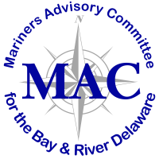

Memorandum

To: Mariners’ Advisory Committee Members and Interested Parties
From: Captain Rick Iuliucci, Treasurer
Re: Treasurer’s Report for September 2021

Balance – for June 2021 $14,695.63

Deposits (June 2021-Sept 2021)

New Member: South Jersey Port Corporation

Total Deposits during the period $ 250.00

INCOME BALANCE $ 14,945.63

Disbursements (June 2021-Sept 2021)

Popi’s Restaurant $ 1,000.00
Balance of copying fee (Staples) from last mtg* $ 215.77
Administration $ 220.00
Email Service (G-mail) $ 116.64
PNC Service Fees $ 4.00

TOTAL DISBURSEMENTS (June 2021-Sept 2021) $ 1,556.41

BALANCE as of September 8, 2021 $ 13,389.22

*for distribution that came in after the June TR was finalized

ANNUAL MEMBERSHIP DUES in the amount of $400 each for 2022 WILL BE SENT OUT IN OCTOBER

