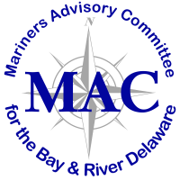

Memorandum

To: Mariners’ Advisory Committee Members and Interested Parties
From: Captain Rick Iuliucci, Treasurer
Re: Treasurer’s Report for June 2022

Balance – from March 7, 2022 $ 18,224.83

Deposits (March 2022-June 2022)

Total Deposits during the period $ 4,399.99

INCOME BALANCE $ 22,624.82

Disbursements (Dec 2021-March 2022)

Popi’s Restaurant (3/14) $ 4,295.01
Popi’s Restaurant Deposit (3/14) $ 1,000.00
Email Service (G-mail- $38.88 month.) $ 116.64
Email service- Twild ($89.95. Per month @ 3 months) $ 179.90
PNC Service Fees ($2.00 per mo.) $ 4.00

TOTAL DISBURSEMENTS (Dec 2021-March 2022) $ 5,595.55

BALANCE as of June 6, 2022 $ 17,029.27

