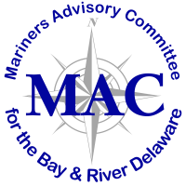

Memorandum

To: Mariners’ Advisory Committee Members and Interested Parties
From: Captain Rick Iuliucci, Treasurer
Re: Treasurer’s Report for March 2022

Balance – from December 7, 2021 $ 11,547.88

Deposits (Dec 2021-March 2022)

Total Deposits during the period $ 9,309.65

INCOME BALANCE $ 20,857.53

Disbursements (Dec 2021-March 2022)

Popi’s Restaurant (12/13) $ 300.46
Popi’s Restaurant (1/31) $ 1,000.00
Christmas Gifts $ 939.80
Email Service (G-mail- $38.88 month.) $ 116.64
Email service- Twild ($89.95. Per month @ 3 months) $ 269.80
Misc. Withdrawal $ 2.00
PNC Service Fees ($2.00 per mo.) $ 4.00

TOTAL DISBURSEMENTS (Dec 2021-March 2022) $ 2,632.70

BALANCE as of March 7, 2022 $ 18,224.83

